Week Three: May 4th-8th
Hola' Dye Scientists and Engineers,
I hope you are healthy and enjoyed last week’s activities. I really enjoyed the pictures and videos you sent me of you investigating and engineering! This week, our activities have to do with weather. You will see the water cycle in action and engineer a rain gauge. Hopefully, you will be able to measure rain and not snow.
As a family you can do the STEM activities or you can watch the video, reading material, vocabulary, discussion questions and an online quiz that correlate to the lesson. Please remember, these are simply for enrichment and are not required. These are great opportunities to learn something new and test your knowledge without worrying about a grade.
You will continue to have other building challenges in the coming weeks. Keep saving clean, recyclable materials (pop bottles, toilet paper rolls, cardboard, cereal boxes, grocery bags, old mail, cans, bread ties, etc.), so that when the time comes, you will have materials for the activities. If you started last week, hopefully you already have a pop bottle for this week’s activity.
I want to hear from you this week! A few have sent me messages and pictures, but I WANT MORE! ;-) Send me a picture of you doing your water cycle bowl or a picture of your final rain gauge. If you take the quiz, share your score with me. Tell me something you learned from the video or the reading material. Did you take the lesson a step further? Tell me how.
If you contact me with any of these things I will send you back a Science Joke!
Contact Information: Class Dojo-STEM Teacher Mrs. Thomas, email clthomas@carmanainsworth.org, or text 810-412-8829 or visit my website dyeelementarystem.weebly.com.
I hope your family is healthy and safe. Have fun with S.T.E.M. this week, and let me know how it goes!
Adios amigos,
Mrs. Thomas

Activity 1
https://www.generationgenius.com/?share=0CBBF
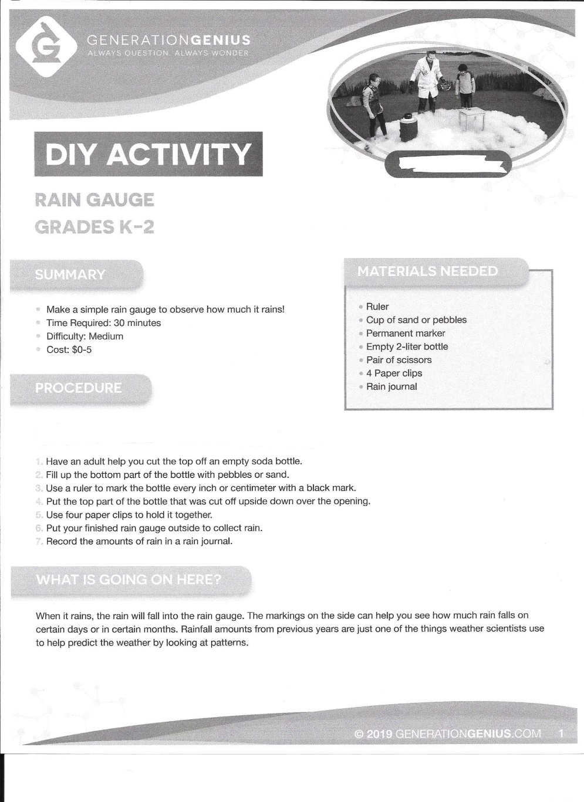
Rain Gauge Suggestions:
- You can use any size pop bottle for the activity.
- The pebbles or sand are used to add weight which will hold the rain gauge in place. You can also use pennies, rice, dried beans, marbles, rocks, etc.
- Instead of 4 paperclips, you can also use tape to hold it together.
- Take the activity a step farther, and compare your results to your local weather report.

Activity 2
https://www.generationgenius.com/?share=0476F
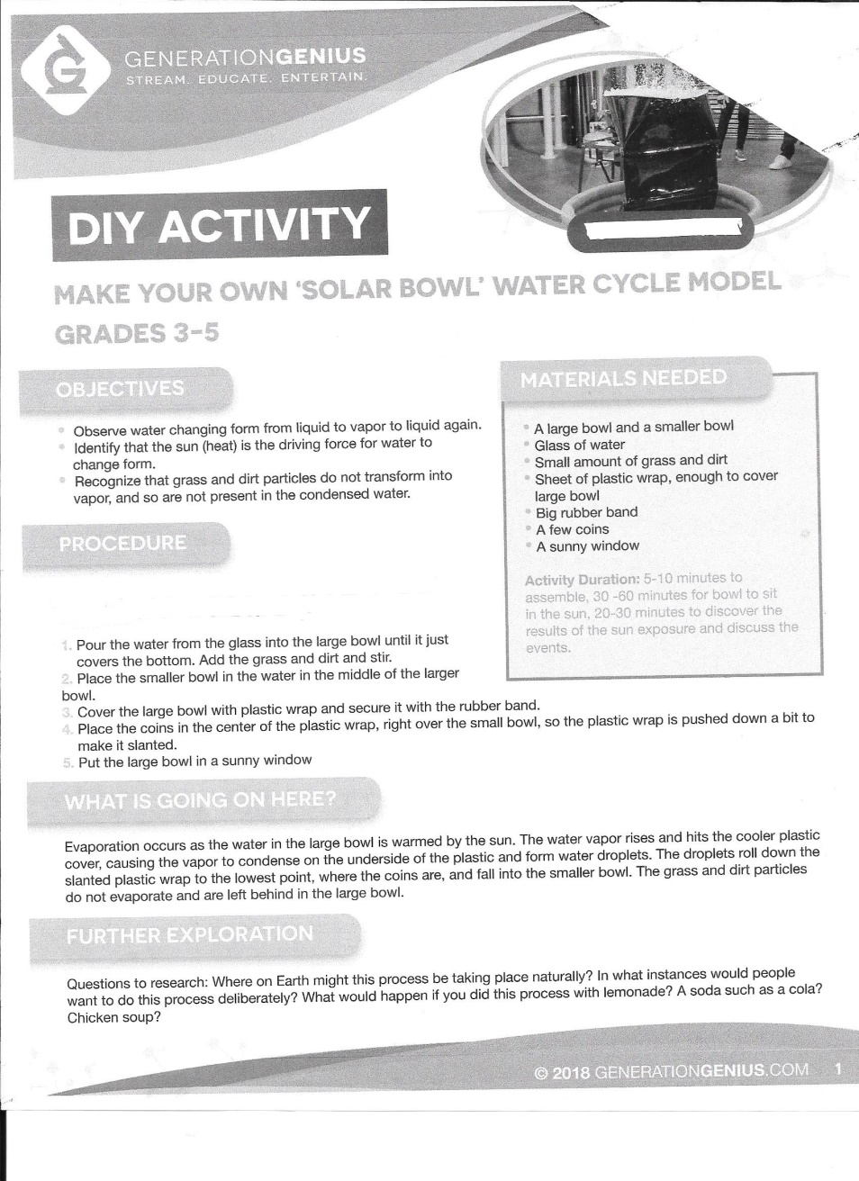
Water Cycle Model Suggestions:
- If dirt and grass are not available, use pepper or any other items to represent solids.
- If you don't have a rubber band, you can tape the plastic wrap to the bowl or tie a shoe string around the bowl to hold the plastic wrap in place.
- Look for ways to expand this activity in the Further Exploration section of the link.

